FISH 604 Your Name: Genoa Sullaway
Final examination
December 7, 2021 PLEASE TURN ON 'TRACK CHANGES BEFORE YOU START!!!

TOTAL: 60 points

1. Which of the following models in (a) are most appropriate in addressing the problems described in (b) (15 points – 1.5 per model):

(a) Analysis of variance model (ANOVA)
Linear Model (LM)
Generalized Linear Model (GLM)
Generalized Additive Model (GAM)
Zero-inflated Poisson or Negative Binomial Model (ZIP/ZINB)
Nonlinear model (NLM)
Linear mixed-effects model (LME)
Generalized Linear mixed-effects model (GLME)

(b) Enter your answers in the last column:
Type of response | Type of predictor variable | Relationship between response and predictor | Model?
Poisson or over-dispersed Poisson counts | Continuous and / or categorical | Linear or linear on log-scale | Generalized Linear Model (GLM)
Binomial (0/1) | Continuous and / or categorical | Unknown, possibly non-linear | Generalized Additive Model (GAM)
Count data with excessive zeros | Continuous and / or categorical | Linear or loglinear (=linear on log-scale) | Zero-inflated Poisson or Negative Binomial Model (ZIP/ZINB)
Continuous, normally distr. | Continuous and / or categorical | Non-linear with known parametric form | Nonlinear model (NLM)
Continuous, normally distributed | Categorical | No particular relation (different means by group) | Analysis of variance model (ANOVA)
Continuous, normally distr. | Continuous and / or categorical | Linear | Linear Model (LM)
Continuous, normally distr. | Continuous and / or categorical – at least one grouping variable | Linear, random differences among groups | Linear mixed-effects model (LME)
Poisson or Neg. Binomial Counts | Continuous and / or categorical | Linear (within groups), random differences among groups | Generalized Linear mixed-effects model (GLME)
Continuous, normally distr. | Continuous and / or categorical | Unknown, possibly non-linear | Generalized Additive Model (GAM)
Binomial (0/1) | Continuous and / or categorical | Linear on logit scale | Generalized Linear Model (GLM)

2. True or False? (6 points)

- When comparing GLM fits using the AIC model selection criterion, all models to be compared should be fit via restricted maximum likelihood (REML)

FALSE

(b) You can use algorithms for fitting generalized additive models (GAMs) to fit any generalized linear model.

TRUE

(c) The Akaike weight for a model (as used in model selection) is inverse proportional to the variance of the residuals.

FALSE

(d) As the bandwidth of the smoothing window for a LOWESS smoother increases, so does the number of equivalent parameters ("equivalent degrees of freedom")

TRUE

(e) Non-independent residuals (for example spatially autocorrelated residuals) result in standard errors for parameter estimates and predicted values that are larger than they should be.

FALSE

(f) The autoregressive parameter in a time series model ranges from -1 to 1
TRUE

3. Interpreting output from an additive mixed-effects model (30 points)
This example examines variability in the condition of walleye pollock by modeling individual weight as a function of body length and as a function of temperature. Differences in weight at a given length should reflect their condition (how 'fat'; they are). Condition may differ in part as a result of differences in temperature, which affects their growth potential. Similar to earlier examples that you saw in class, both length and weight are log-transformed first to linearize the relationship (Fig. 1).
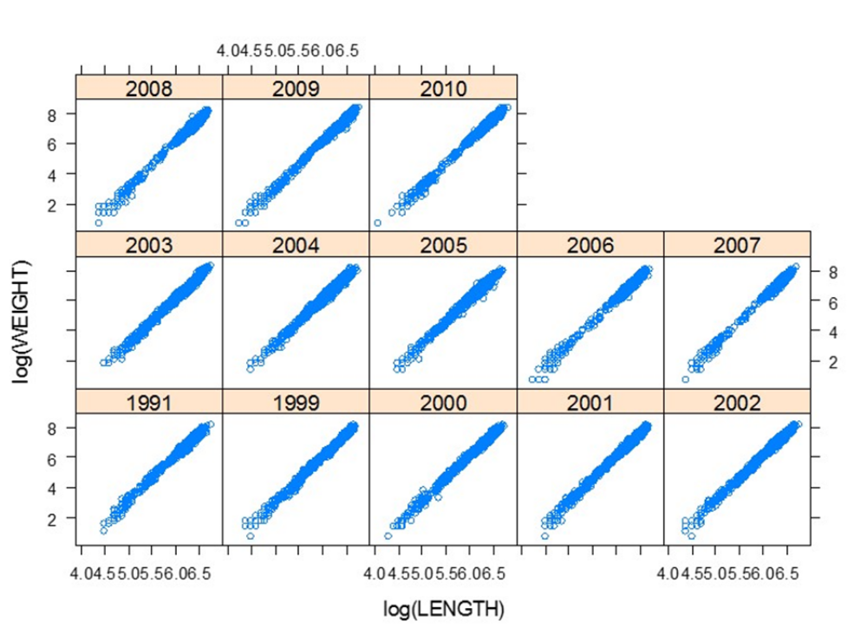
Figure 1: Weight-length relationships (log-scale) for walleye pollock by year.

Data & sampling design: Fish were randomly sampled during the summer in 1991 and 1999-2012. Sampling occurred over an extended period each summer and started as early as mid-May in some years, and sometimes extending through mid-August. In addition to the location and the day of sampling, the local bottom water temperature at the time of sampling was recorded at each station.

Average weights (adjusted for length) are expected to differ among years for other reasons (besides temperature effects) due to differences in feeding conditions, etc. Our goal is to describe how weight (on log-transformed scale) varies over the sampling season (i.e. by day of the year) and as a function of water temperature (Temp). In addition, we are interested in how the weight-at-length relationship may vary among years. Therefore, variability in weight among years was modeled as a random effect in the context of a generalized additive model as follows:

(Model 1)

where W_{i,t} and L_{i,t} are the weight and length, respectively, of fish i in year t, day is day of year on which the fish was sampled, Temp is the local temperature where the fish was sampled, f₁ and f₂ are smooth non-parametric functions, and ε_{i,t} is the residual for fish i in year t. The residuals are assumed to be independent, normally distributed with mean 0 and standard deviation σ_{ε}².

The parameters α and β are the intercept and slope for the average weight-length relationship (estimated as fixed effects) and a_{t} and b_{t} are the random intercept and slope for year t, which captures differences in the weight-length relationships among years that are unrelated to time of year and local temperature. The year-specific intercepts a_{t} and slopes b_{t} are assumed to be randomly distributed with mean 0, variances σ_{a}², σ_{b}² and covariance σ_{ab}.

The model has three components: the (fixed) parametric coefficients [intercept and slope for log(Length)], the smooth terms (non-parametric smoothing splines fit by the function ‘s’) and the random effects (intercept a_{t} and slope b_{t} by year t). Here's a summary of the model output for each component:

Family: gaussian
Link function: identity

Formula:
log(WEIGHT) ~ log(LENGTH) + s(Julian) + s(TEMPERATURE)

Parametric coefficients:
Estimate Std. Error t value Pr(>|t|)
(Intercept) -12.10392 0.06691 -180.9 <2e-16 ***
log(LENGTH) 3.02682 0.01181 256.3 <2e-16 ***
---
Signif. codes: 0 ‘***’ 0.001 ‘**’ 0.01 ‘*’ 0.05 ‘.’ 0.1 ‘ ’ 1

Approximate significance of smooth terms:
edf Ref.df F p-value
s(Julian) 2.925 2.925 97.68 <2e-16 ***
s(TEMPERATURE) 6.345 6.345 186.85 <2e-16 ***
---
Signif. codes: 0 ‘***’ 0.001 ‘**’ 0.01 ‘*’ 0.05 ‘.’ 0.1 ‘ ’ 1

R-sq.(adj) = 0.994
Scale est. = 0.015263 n = 18834
Random effects:
Formula: ~log(LENGTH) | YEAR

StdDev Corr
(Intercept) 0.237 (Intr)
log(LENGTH) 0.042 -0.997
Residual 0.124

(a) (4 points) Summarize all parameter estimates (see equation above for names of parameters) in the table below (there are no estimates for the grey cells):

Parameter | Estimate | Standard error
α | -12.10392 | 0.06691
β | -9.0771 | 0.01181
σ_{a} | 0.237
σ_{b} | 0.042
σ_{ab} | -0.997
σ_{ε} | 0.124

(b) (2 points) What is an approximate 95% confidence interval for the average slope of the linear relationship between log(Weight) and log(Length)? You can approximate the CI using:

slope ± 1.96*SE = (-9.100248, -9.053952)

(c) (2 points) The output includes a Wald’s t-test for the average slope (β). What is the null hypothesis for this test and what can you conclude from the t-test?
The null hypothesis is that the term is not a significant addition to the model. Here, it indicates that the average slope is a significant explanatory variable in the model.

Figure 2 below shows the estimated effects of temperature and day of sampling on pollock weight. These effects are adjusted for differences in length and can therefore be interpreted as weight anomalies (a measure of condition). These anomalies describe how weight at a given length differs from the expected (or average) weight of a pollock at that length.

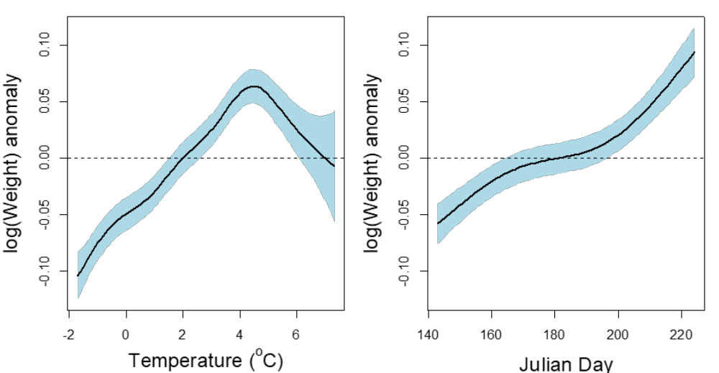

Figure 2: Estimated effects of temperature and Julian Day on log(Weight) of walleye pollock after accounting for effects of log(Length) with approximate 95% confidence intervals.

(d) (3 points) The model output includes estimated degrees of freedom (edf) for each of the smooth terms in Figure 2, which were fit using piecewise cubic regression splines defined by equally-spaced 'knots'. The amount of smoothing (i.e. the value of edf) in this final model was chosen by cross-validation. Explain conceptually how the number of knots, the edf, and cross-validation are related.

All three of these entities work together, rather iteratively to determine the appropriate model fit and degree of smoothing. The spline segments in the cubic regression spline are joined together by knots, the number of knots incorporated reflect the amount of parameters used in the model, shown in our output as edf. Because these models are not parametric, we don’t know how many should be incorporated into the model so cross-validation helps us determine the amount of smoothing that should be in the model. This occurs by removing a data point one at a time, testing a range of smooths (lambda) and seeing the optimal lambda that minimizes the residual sum of squares.

(e) (3 points) Based on the statistical output given and on the estimated relationships between log(Weight) and temperature and between log(Weight) and Julian day (Figure 2), briefly summarize the results and conclusions from the model with respect to the effects of temperature and day of sampling on pollock weight-at-length.

It looks like fish weight becomes larger than expected as temperature increases. This is a non-linear relationship and at high temperatures weight anomalies decrease, indicating a threshold effect where fish body conditions decreases at high temperatures.
Fish weight is larger than expected as Julian day increases so fish start of smaller than expected and get fatter as Julian day increases.

(f) (2 points) What are the mean values of a_{t} and b_{t}?
We assume mean value for random effects are 0.

(g) (3 points) Based on the random effects results above and Figure 3 below, which shows the estimated random effects both graphically and numerically (as year-specific values of the intercept a_{t} and the slope b_{t}), either write an equation for or compute the predicted mean log(Weight) of a pollock that has a log(Length) of 6.

- since it is just a mean across all years, I set a and b = 0.
Log(Weight) = -12.10392 + 3.02 * 6

Just to be sure… if you asked for a specific year then we would add the random effect of at and bt in for the specific year in question (or for each year in a vector format).

Log(Weight)_{t} = -12.10392 + 3.02 * 6 + a_{t} + b_{t}*6

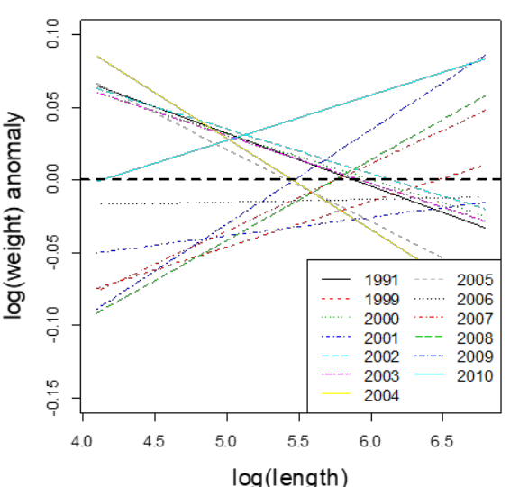

Random effects

a_{t} b_{t .}
(Intercept) log(LENGTH)
1991 0.214 -0.0364
1999 -0.204 0.0316
2000 0.189 -0.0314
2001 -0.103 0.0130
2002 0.189 -0.0308
2003 0.195 -0.0329
2004 0.342 -0.0627
2005 0.271 -0.0499
2006 -0.024 0.0017
2007 -0.266 0.0462
2008 -0.319 0.0556
2009 -0.354 0.0648
2010 -0.129 0.0312

Figure 3: Random variability in intercepts and slopes of the length-weight relationship. Estimated random effects are shown on right and year-specific deviations from the average weight-length relationship are shown on the left.

Pollock for this study were sampled on a grid of sampling stations on the southeastern Bering Sea shelf, and there is likely spatial autocorrelation in the model residuals. The latitude and longitude of each station is known:

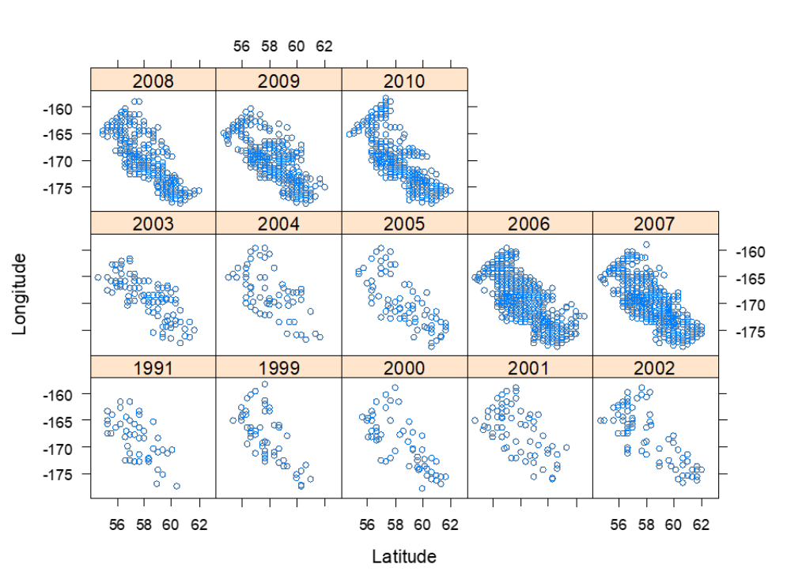
Figure 4: Maps of stations sampled for pollock length/weight data on the eastern Bering Sea shelf by year.

(h) (3 pts) Very briefly describe what spatial autocorrelation means in this context and how it could be described and/or quantified.
Spatial autocorrelation here means that a pollock is likely to be similar to a pollock close to it rather than a pollock from farther away, basically breaking the assumption of independence and could lead you to over estimating significance and underestimating confidence intervals. This could be described and quantified by a semi-variogram, which estimates the relationship between points as function of the distance between the points. The semi-variogram fits the best covariance functions for the data. This information can be incorporated into a variance covariance matrix with the goal to account for spatial autocorrelation in the residuals.

(k) (3 pts) Briefly outline how you could conceptually incorporate spatial autocorrelation into the model.
We can incorporate the appropriate spatial autocorrelation structure, identified by fitting the correlation functions to a semi-variogram, into a model (ie. a GLS) by accounting for it in a variance-covariance matrix. Because the pollock model is a GAMM we could use a thin plate regression spline with interaction between lat and lon to create a smooth surface to approximate the relationship and account for the spatial autocorrelation directly in the model.

(l) (5 pts) As an alternative to adjusting for spatial autocorrelation, we can try to account for autocorrelation by fitting a spatial smoother to the data for each year, using a model that includes an additional smooth term:

(Model 2)

The only difference between this model and the one we fit above is the addition of the (year-specific) smooth term s_{t} (φ₁, φ₂), where s_{t} is a smooth function for year t, φ₁ denotes longitude and φ₂ denotes latitude (or some distance measure in the east-west and north-south direction, respectively). The maps below (Figure 5) show the estimated smooth surfaces of log(W) anomalies for four selected years:

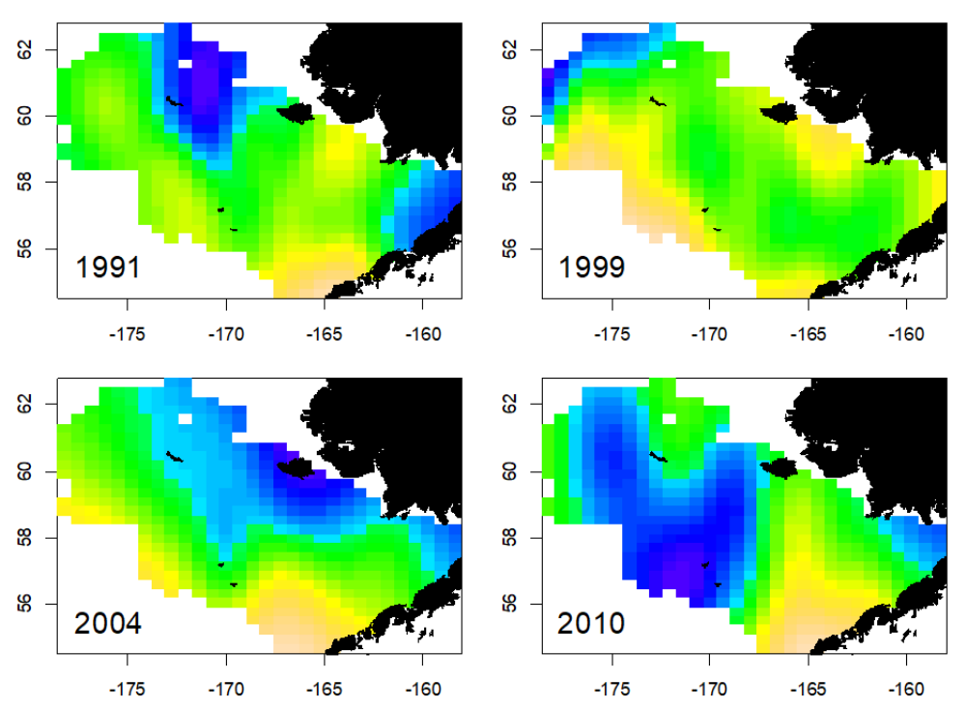
Figure 5: Spatial anomalies in log(W) at length 250 mm on Julian day 180 and at the mean temperature in a given year for four selected years. Blue denotes areas with negative anomalies, yeallow and tan denote positive anomalies.

Estimating the spatial anomalies by year changes the estimated seasonal trend and the temperature relationship substantially (Figure 6) from our initial model that did not include spatial anomalies:

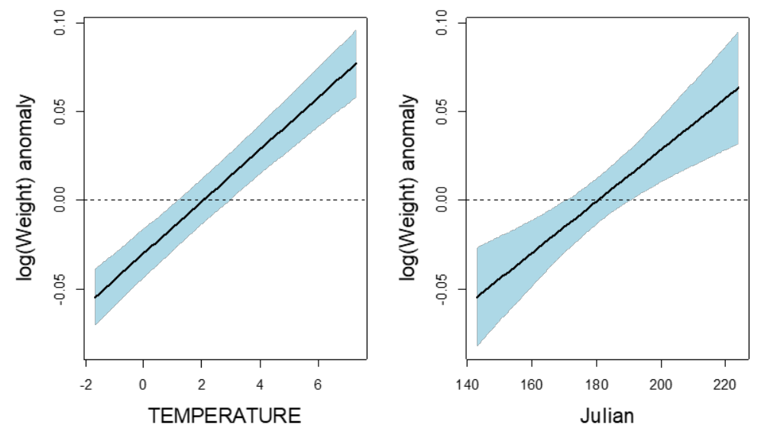

Figure 6: Estimated effects of temperature and Julian Day on log(Weight) of walleye pollock after accounting for effects of log(Length) and adjusting for spatial anomalies with approximate 95% confidence intervals.

We can compare the two models using an analysis of deviance that compares the likelihood of the two models based on the AIC and a likelihood ratio test (output simplified). Note that the model df listed here in this case does not correspond to the total estimated number of parameters from the GAM smooths for reasons that I did not get into, but they are the appropriate number of parameters for model comparisons.

> anova(Model1, Model2)
df AIC logLik Test L.Ratio p-value
Model1 10 -25168 12594
Model2 49 -26645 13372 1 vs 2 1555.23 <.0001

Explain conceptually the principle behind the likelihood ratio test and the AIC for comparing the two models. What is your conclusion from these comparisons?

AIC weighs the difference between model complexity (informed by q) and model fit, using loglikelihood, and compares relative differences across models. The likelihood ratio test looks to see if the ratio between the loglikelihoods in the two models is different than 1, the p-value indicates if the ratio is or not different than 1. My conclusion is that incorporating spatial autocorrelation significantly improved model fit and model2 is the better model.

Why do you think the estimated relationships between log(Weight) and temperature and between log(Weight) and Julian day may have changed in this model (compare Figures 2 and 6)?

Estimated relationships changed after incorporating spatial autocorrelation because not accounting for autocorrelation can results in biased estimates and biased trends.

4. (9 points) Identify appropriate modeling approaches.
Given the information provided, which of the following models are most appropriate for addressing the problems in the three scenarios described in the table below? For each, provide a brief rationale of your choice below the table.

Linear Model (LM)
Generalized Linear Model (GLM)
Generalized Additive Model (GAM)
Linear mixed-effects model (LME)
Nonlinear mixed-effects model (NLME)

Scenario | Model?
1. An ocean scientist is interested in describing the average vertical profile of light absorption in the ocean and how much variability there is in the profile (i.e. in the parameters I₀ and k, Figure 7) among different locations. She samples 15 representative (randomly selected) locations and measures irradiance at different depths in the ocean (see Fig. 4, note that the response, i.e. irradiance, is on the x-axis in this case). | Nonlinear mixed-effects model (NLME)
2. A biological oceanographer measures the amount of bioluminescence in three different water masses in the Indian Ocean basin, based on discrete water samples taken between 500 and 3000 m (Figure 8). He wishes to describe the complex pattern of bioluminescence with depth at each location separately and compare patterns among the three regions. | Generalized Additive Model (GAM)
3. A biologist compares the number of diatom species (ranging from 0 to 6) among four fjord systems in SE Alaska and among three seasons to estimate the mean count by fjord and season. Each fjord was sampled in spring, mid-summer and fall, and 10-15 replicate samples were taken in each season/fjord combination. | Generalized Linear Model (GLM)

Rationale:
1. NLME because the relationship is nonlinear with a known parametric form. Mixed effects because the researcher is surveying from random locations that should be representative of all possible locations. Location would be a random effect here.
2. I chose GAM because it sounds like the distribution will be a discrete distribution (not normal) and the functional form is “complex”, so GAM can help estimate the relationships, they may or may not be linear. Oh and the figures below look non-linear.
3. I chose GLM because it sounds like the distribution will be count data, so they will need a non-normal distribution to compare differences in means. However, if data can be log transformed and approximately normal, I think you could also just use an Linear model (ANOVA)?

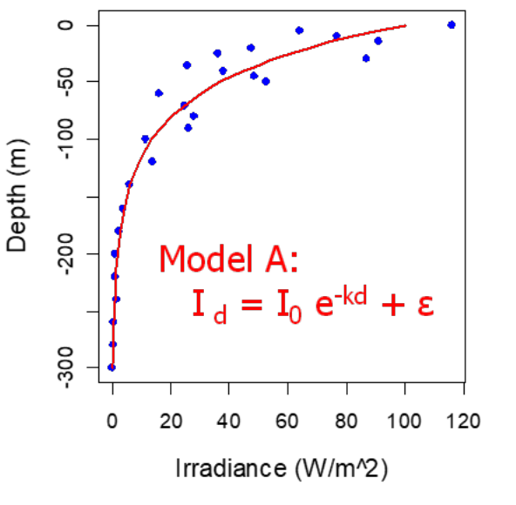
Figure 7: Vertical irradiance profile characterizing light absorption in the ocean. Irradiance at depth d is modeled as an exponential decline with depth with parameters I₀ = irradiance at the surface and k = "vertical extinction coefficient" (rate of absorption).

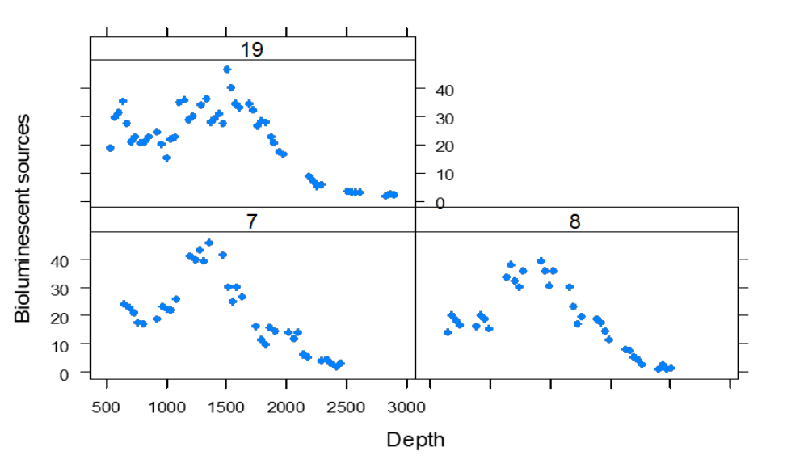
Figure 8: Bioluminescence at depth in three different water masses

